**Module Title**

**Academic English and Effective Communication**

**Assessment Weightage & Type**

**40% Final Site**

**Year**

**2024-25**

**Student Name: Asim Nath Pant**

**UWE ID: 24071188**

**Assignment Due Date: April 11, 2025**

**Assignment Submission Date: April 11, 2025**

## Table of Contents

Introduction………………………………………………………………….……………….. 3

Tools and Technologies Used……………………………..…………….…………………… 4

Website Structure……………………….……………………………….…………………… 5

Screenshots………………………………………...……………….………………………… 6

Features…………………………………………………………….………………………… 9

Conclusion……………………………………………………….………………………….. 10

## Introduction

The Oak Leaf Flames project is a simple yet visually engaging static restaurant website, developed using core front-end technologies such as HTML and CSS. This website is designed to offer visitors a smooth and user-friendly experience while exploring key aspects of the restaurant, including its menu, background story, image gallery, and contact details. The layout is intuitive and consistent across all pages, ensuring easy navigation for users of all age groups.

The primary objective of this project is to apply and demonstrate fundamental web design principles, with a strong emphasis on page structure, visual styling, and user interaction. Elements such as a fixed background, responsive buttons, hover effects, and a well-organised navigation bar contribute to the site’s professional appearance. Through this project, essential concepts in static web development—like content alignment, typography, and colour schemes—were explored and implemented, making it a valuable learning experience in front-end development.

## Tools and Technologies Used

* **HTML5** – for structuring the web pages
* **CSS3** – for styling and visual design
* **Visual Studio Code** – as the code editor
* **Google Chrome** – for testing and previewing
* **Image Assets** – including image and other resources

## Website Structure

The website consists of the following five main pages:

* **Home (Index.html):** Contains a welcome message, navigation menu, and buttons linking to other pages.
* **Menu (Menu.html):** Displays food items with images, descriptions, and prices.
* **About (About.html):** Provides background information about the restaurant.
* **Contact (Contact.html):** Includes a form for user inquiries and contact details.
* **Gallery (Gallery.html):** Showcases food and restaurant images in a structured table layout.

## Screenshots

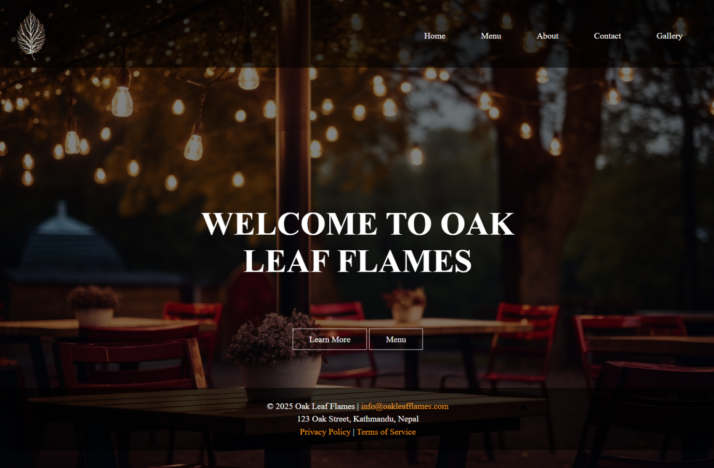

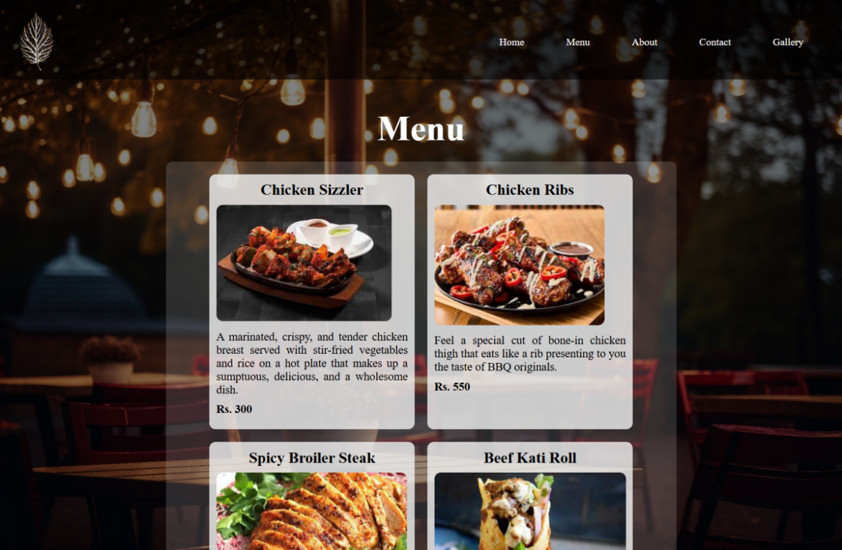

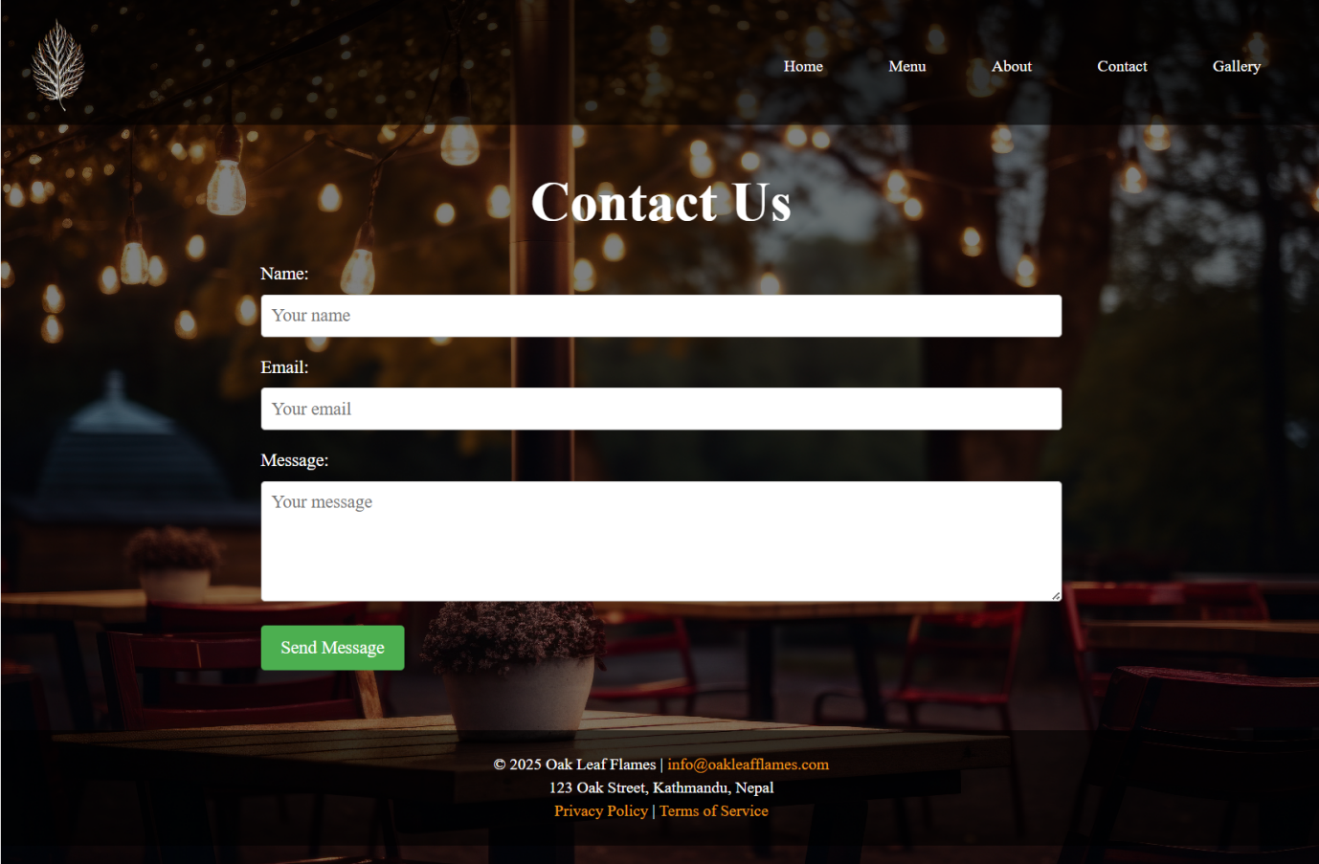

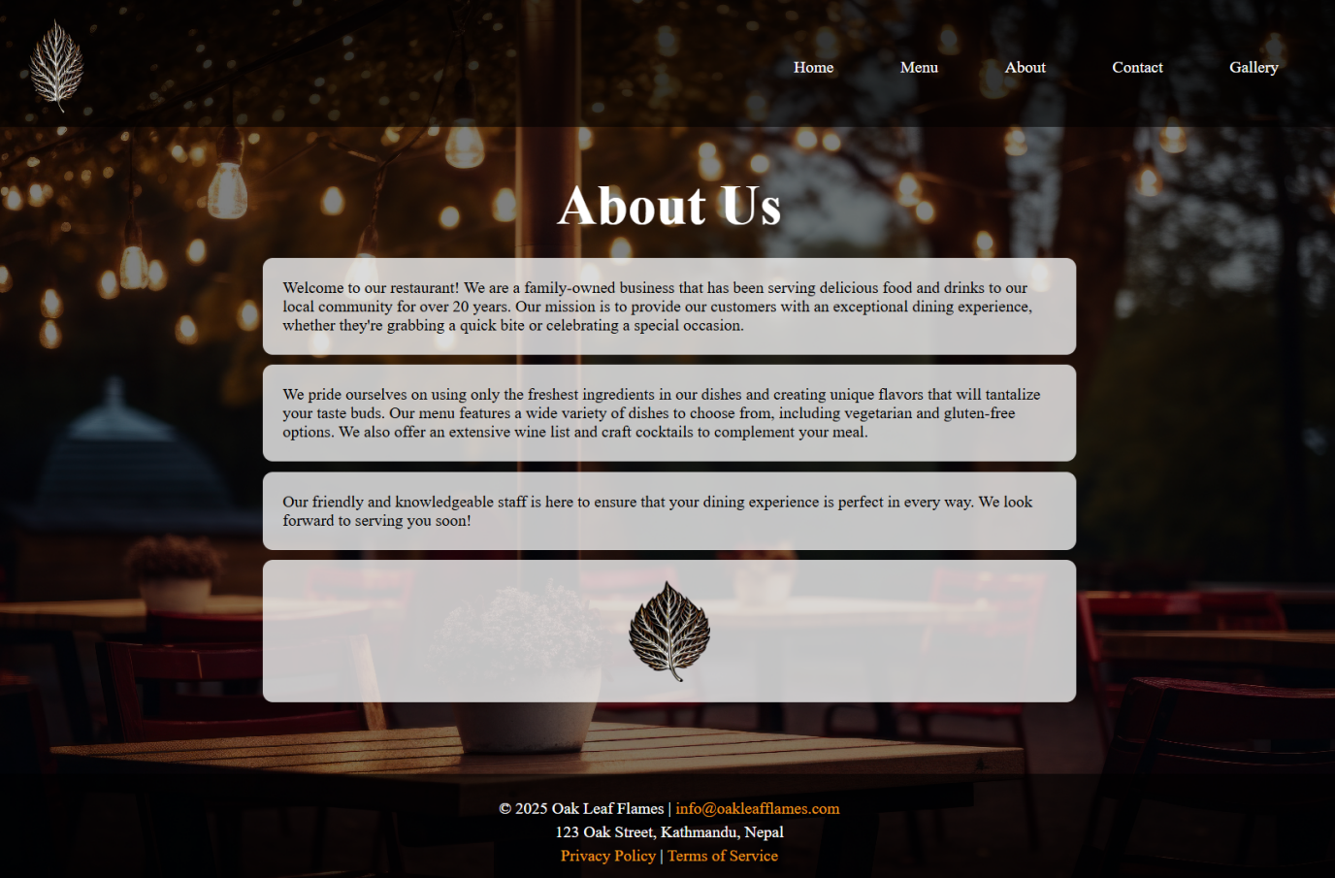

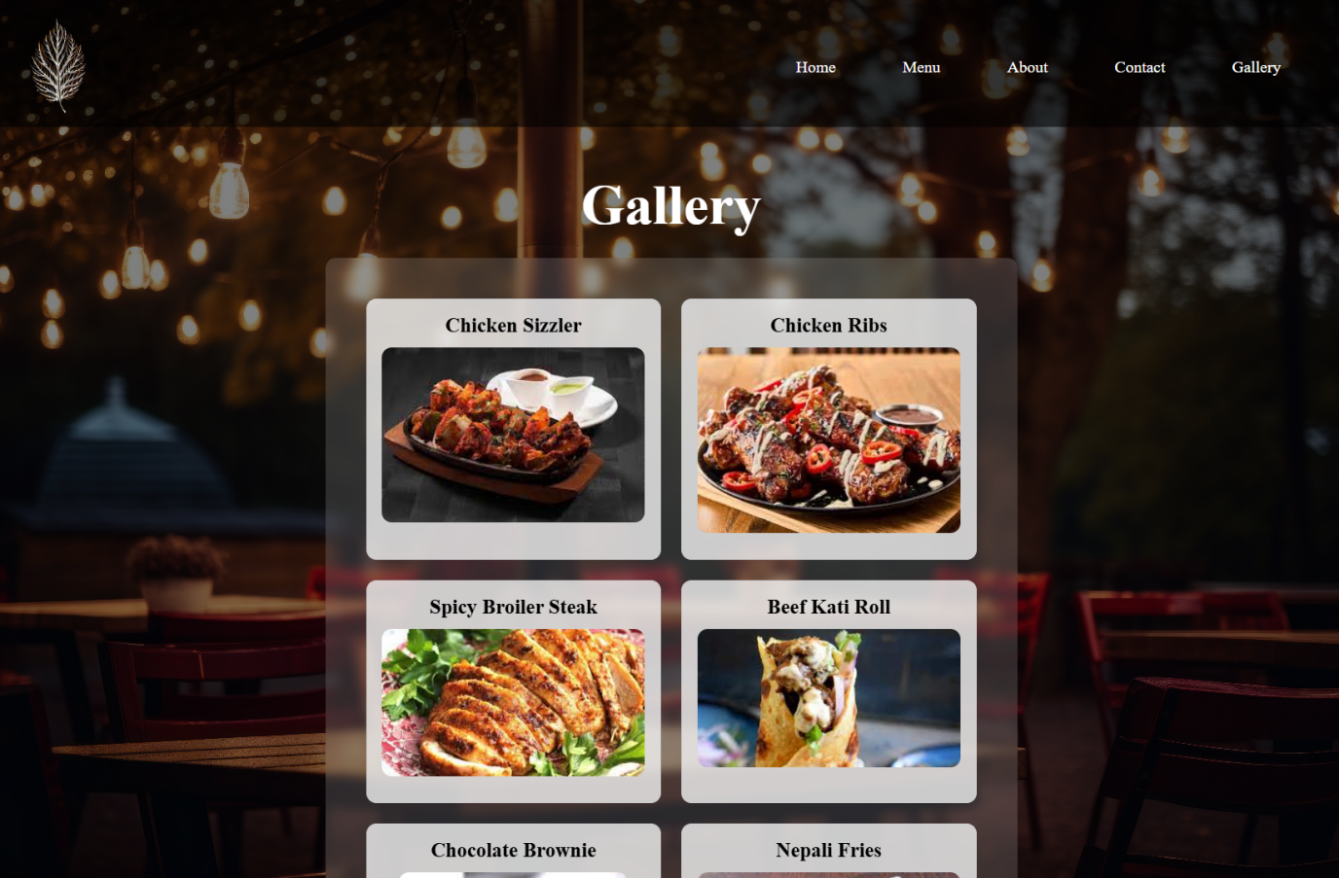

## Features

* Responsive layout with fixed background image
* Navigation bar available across all pages
* Hover effects on menu and buttons
* Contact form for user interaction
* Consistent branding using logo and colour theme
* Footer with contact information and policy links

## Conclusion

This project demonstrates the effective use of core web development technologies, specifically HTML, CSS, and JavaScript, to build a fully functional and visually engaging restaurant website. It applies essential design principles such as layout consistency, readability, and intuitive user navigation to create a smooth and enjoyable browsing experience. Every section of the website has been carefully structured and styled to maintain clarity, simplicity, and aesthetic appeal.

Through this project, practical skills in front-end development were significantly improved. Particular focus was given to mastering techniques such as Flexbox for managing page layout, element positioning, and implementing responsive design to ensure the website displays well across various screen sizes. Attention to detail was shown in the use of typography, colour schemes, spacing, and subtle hover effects, which all enhance the site's professional look and feel. Overall, the project serves as a strong foundation for developing more advanced, interactive, and user-friendly web applications in the future.